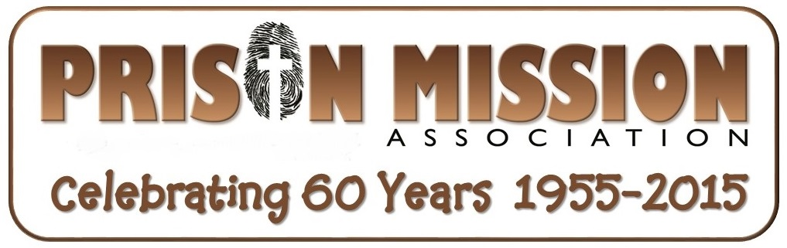

10 min. talk about what God is doing through Prison Mission

"Thank God I went to prison to find the Grace of God!" said Edward…

“I grew up in a catholic home in Philadelphia. I did not know God as my Lord or personal Savior. They taught me that I had to “do good works” in order to receive the grace of God. During my growing up years, my parents continually beat my brother and myself, almost daily because whatever we did was not perfect. I soon fell into rebellion and began taking drugs, and drinking. At 17 years of age, in 1982, I fell into prison and have been sentenced to life imprisonment. I am sorry for what I did, truly.

While here in prison, a cell mate asked me if I would like to do a Bible Correspondence course. Why not, I told him. One of your courses in particular, was of Works vs. Grace. When I finished it, I understood for the first time the Grace of God. The Holy Spirit opened my eyes and I opened my heart to Him, deciding to follow Jesus.

I understand the love of God. I study the Word every day, walk within His commandments and pray daily. I would like to study the Bible more, possibly taking college courses. I want to learn more in order to teach others about Grace and the peace found in our Lord.”

Edward took our Spanish bible courses and he is one of many testimonies we have coming in almost every day now!

"I found out in prison, I had full blown aids!”

That's what Antonio I. said. . This is his testimony:

I have been incarcerated for almost six years now, I thank our Lord that this journey is almost over. I have 9 months remaining on my sentence. Several factors played a role in my return to Jesus. I say return because I was raised in a Catholic family, going to church on a regular basis until my teen years when I veered away from the church.

I began traveling down the path of my own self-destruction. I used as many drugs as I could get my hands on and I was always the life of a party, out drinking all the people who at the time I thought were my friends. I was also very promiscuous, especially during my college years. Finally it caught up with me and I came to prison with a 15 year, split sentence (7 in & 8 probation). In my first month, I also found out I was HIV. Within 4 months of my diagnosis, I had full blown Aids.

I prayed and asked to be forgiven and I began my Prison Mission Bible studies. I accepted Jesus as my Lord and Savior in the summer of 2010. Since then, I have had peace in my life and our good Lord has really looked out for me. Not only is my HIV undetectable but my while blood cells are in the normal range. God inspired a doctor to create the medication Atripla and I am living proof that prayer works! PMA came into my life by a brother in Christ who gave me a one-way ticket! (hold up our PMA one way ticket enrollment card so they can see it) I enjoy doing the studies because they really help me to dig into the word and find meaning. I always look forward to the responses written when I receive my lessons after being graded. I look forward to many more enlightening lessons. Thank you for all your love and devotion to the ministry. Antonio I.

Prison Mission Association Informational Statement

Prison Mission Association is a ministry with the mission statement to “Reach Prisoners for Christ!” Started by Joe Mason in 1955, our purpose has been sharing the Gospel with inmates and providing them with Life Changing Bible correspondence courses. Today, we distribute lessons to all 50 states, in English and Spanish. In the last 14 years, we have had over 20,000 students enrolled. We are blessed to celebrate 60 years of ministry this year!

As members of local churches like yours, Prison Mission Association visit congregations to let you know how God is using the seeds being sown. We are part of the local church and work with believers like you to spread the Gospel in as many jails and prisons as we can.

By God's grace, we distributed over 4,369 Bible Correspondence Fellowship Lessons last year. What a true blessing: to see hundreds of lives changed by the power of the Gospel...through your prayers and donations.

We have many lesson correctors who volunteer each day to correct lessons. The correctors write words of encouragement and biblical counsel which provides and important spiritual link for these men and women behind bars! PMA volunteers also visit jails and prison with local churches to distribute our Free Bible lessons.

Pray for our staff, Dwight Anderson, director, in Minnesota, working to double our number of students by recruiting more people to reach out to prisons, raise needed support for his part time salary. Mariana Selfors, does our Spanish ministry correcting in SpringHill, FL. Mariana took over from Sally Selfors when she went to be with jesus. Pray for Karen Bodeutsch, operations manager at the home office in Washington, as she coordinates volunteers and administers PMA’s home office.

Closing statement
Here's a number to think about: [pause] 2.3 million! That is how many men and women are in prison in the United States of America! Many of those need to hear the good news of the Grace of God! So how can you help reach them?

First and foremost, pray for Prison Mission Association. Pray that we will have more "open doors" to distribute bible lessons...have more funds to print and distribute...and have more volunteers visit prisons to distribute our bible lessons to those who don't know the Lord as their Savior.

Next, if God leads you to do so, please consider giving to the Prison Mission ministry. When you give to Prison Mission Association, you help impact lives for Christ. For an investment of about $25, you can provide Life changing lessons for two inmates. This includes all the costs involved in printing, postage, and handling, to get them into the hands of someone who needs it.

The testimonies you've heard me share today were made possible by gifts from people just like you. That is how Prison Mission Association have accomplished this ministry for over 60 years—as part of the church. We are an extension of your church's ministry to the prisons. We can mail our lessons to many places where individual churches and denominations can't get to. Our FREE correspondence course is what sets us apart from other Prison ministries. Upon completion of all our self-paced 35 lessons (usually about 2 years), inmates can transfer to Berean Bible Institute and earn up to 6 credit hours towards electives.

At the close of your service today, you will have the opportunity to help support Prison Mission Association. [Please confirm that an offering will be taken.]

For your convenience, you can make a check payable to "Prison Mission Association" or use the credit card form that is available in your bulletin insert. [Make certain bulletin inserts will be permitted.]

There is a way for you to magnify your impact—you can set up a monthly gift using the donation form card. You can also donate online at our new website www.prisonmission.org

We are facing a critical time right now at PMA and need to raise about $900 per month. We are praying for 15 more people or churches to give $50 per month and 10 more to give $25 per month to meet this goal.

You may feel led of the Lord to visit prisons and want to help us distribute our lessons or share what God is doing in churches, please pray about how you can get involved as a volunteer! You can download all our lessons from our website – www.prisonmission.org and use for follow-up and personal bible study.

[Turn to pastor] Thank you, pastor [turn back to audience] and congregation, for granting me this time to talk about the Prison Mission Association ministry and—through your prayers and donations—its impact around the United States! Please continue to keep Prison Mission ministry in your prayers. May God bless you.

