
Gospel of John
Lesson 3 Chapters 8-10
Chapter 8

In chapter 7 we saw Jesus teaching in the temple and causing the people to make decisions about who He was, where He came from and on whose authority He healed on the Sabbath. At the end of the chapter, we saw that the Pharisees sent out officers trying to trap Jesus, but the officers did not, because Jesus’ words made such on impact in their hearts. Nicodemus corrected the Pharisees understanding of the law; they then accused Nicodemus of coming from Galilee also.
Depending on what version is used, V1-11 are either missing or in italics because that passage was not in some of the earlier manuscripts. However, since there are no doctrinal issues with this passage, it will be used for the lessons.
In this chapter we will see Jesus exposing the Pharisees’ hypocrisy in bringing the woman caught in adultery to Jesus.
We will continue to see the contention between Jesus’ claims of who He is and where He is from, that the unbelieving are not from their father Abraham, and Jesus’ second “I AM” statement.

Please memorize the following verse and be prepared to write it out at the end of this lesson.

John 10:10 The thief does not come except to steal, and to kill, and to destroy. I have come that they may have life, and that they may have it more abundantly.

Read V1-11 and answer the following questions. Check _________

1a. (V1-11) According to the law in Lev. 20:10, who is missing? ___________________________________________
1b. V1-6) What was the trap the Pharisees were trying to catch Jesus in? ____________________________________
_______________________________________________________________________________________________
_______________________________________________________________________________________________
2a. (V7-8) What do you think Jesus wrote on the ground? _________________________________________________
_______________________________________________________________________________________________
2b. What famous phrase did Jesus say to the accusers of the adulterous woman?
A) “Do unto others as you would have them do unto you.”
B) “Let him who is without sin among you be the first to throw a stone at her.”
C) “You are whitewashed tombs.”
D) “Love your neighbor as yourself.”
3. Where else did the finger of God write? Exo.31:18 ____________________________________________________
Dan. 5:5 _____________________________________________________________________________________

4a. (V7) Why would Jesus say, “Let any one of you who is without sin be the first to throw a stone at her.”?_________
_______________________________________________________________________________________________

4b. How did the crowd respond to Jesus’ challenge regarding the woman caught in adultery?
A) They arrested her
B) They argued with Jesus
C) They all left one by one
D) They prayed for her
5. (V8-11) Why did the woman’s accusers leave? _______________________________________________________
6. What did Jesus tell the woman after forgiving her? ____________________________________________________
7. What does this event teach us about God’s forgiveness? ________________________________________________
_______________________________________________________________________________________________
Read V12-20 and answer the following questions. Check _________
8a. (V12) In John 8:12, Jesus declares:
A) “I am the way, the truth, and the life.”
B) “I am the good shepherd.”
C) “I am the light of the world.”
D) “I am the bread of life.”
8b. (V12) What did Jesus mean when He said, “walking in light or darkness”. ________________________________
_______________________________________________________________________________________________
9. (V13) Why did the Pharisees say Jesus’ testimony was not valid?
A) Because He spoke without the Scriptures
B) Because He had no witness
C) Because He healed on the Sabbath
D) Because He was not a Pharisee
10. (V14-18) What evidence did Jesus give that His testimony was valid? ____________________________________
_______________________________________________________________________________________________
11. (V19-20) What is Jesus trying to have them understand about Himself? ___________________________________
_______________________________________________________________________________________________
Read V21-29 and answer the following questions. Check _________
12. (V21 & Acts 1:9) When in the future will Jesus go away? ______________________________________________
13. (V22-26) Jesus said to the Jews, you would die in your sins; if you do not believe that I am He”, Who is the “He” that Jesus is claiming to be? ________________________________________________________________________
14. (V28) What did Jesus mean when He said, “When you have lifted up the Son of Man ...”? _____________________
_______________________________________________________________________________________________
The Greek work for “lifted up” means, to elevate (literally or figuratively) and is translated 20 times as either exalt or lift up. It is used in Jn. 3:14; 12:32; 1 Pet. 5:6. This phrase could be looked at in several ways. 1) referring back to the image of Jn. 3 of looking to him for salvation (like the brass snake in Numbers); or 2) since Jesus is close to the cross now, could it be a reference to the cross; or, 3) by believing in Jesus as the Messiah, you would be lifting him up by exalting him and then you would know the Father.
15. (V25-29) Whose words does Jesus speak, His own or what the Father has for him to speak? __________________
Read V30-47 and answer the following questions. Check _________
16. (V30-31) How is a person a disciple of Jesus? _______________________________________________________
17a. (V31-32) What truth did Jesus say would set people free?
A) The law
B) The words of the pharisees
C) Jesus’ words
D) My definition of the truth
17b. (V31-32) How does Jesus define the word “truth”? ________________________________________________
From V32 to V36 John records Jesus using the word “free” five times. The Greek word means, “to liberate, to exempt from moral, ceremonial or mortal liability”. In 5:33, John the Baptist ‘bare witness unto the truth’ which is the Christ, who takes away the sins of the world, and Jesus said it was by believing on Him. Therefore, the truth is Jesus and Jesus is the truth. “I am the way and the truth and the life. No one comes to the Father except through me” (14:6). Jesus is the truth that sets men free.
18. (V32) What does “the truth” set you free of? ________________________________________________________
While it may sound strange or difficult, the Apostle Paul found joy while in prison. We read in 2 Cor. 11:23-27 of the jails and tortures that Paul received for living a life pleasing to God. Paul found joy in his tribulations because it leads to godly character development (Rom. 5:3-5). Paul understood and taught that when we realize we are weak, we can be strong when we allow Christ to live through us (Gal. 2:20). One of the Holy Spirit’s purposes in our life is to produce the fruit of the Spirit in our lives (Gal. 5:22-23). While things may look bad and even impossible we can be assured that God does have our best interest in mind (2 Cor. 12:9). Also remember, as bleak as some things might look, our sufferings are only temporary compared to eternity. “Therefore, we do not lose heart. Though outwardly we are wasting away, yet inwardly we are being renewed day by day. ¹⁷ For our light and momentary troubles are achieving for us an eternal glory that far outweighs them all. ¹⁸ So we fix our eyes not on what is seen, but on what is unseen, since what is seen is temporary, but what is unseen is eternal”. 2 Cor. 4:16-18
19. (V33) How did the Jews understand the word “free”? _________________________________________________
20. (V34-36) How is Jesus defining the difference between a slave and a son? ________________________________
_______________________________________________________________________________________________
21. (V37-41,44) Who is Jesus saying the unbelieving Jews’ father is? _______________________________________
22a. (V39-47) Who is Jesus saying the unbelieving Jews’ father is not? ______________________________________
22b. When the Jews claimed descent from Abraham, what did Jesus say?
A) “Then you should rejoice.”
B) “You would not seek to kill me if you were truly Abraham’s children.”
C) “Abraham rejoices over your faith.”
D) “You are correct, and you shall inherit the promise.
23. (V41-43) The Jews did not understand Jesus because they were relying on their ____________________________
instead of the __________________________________.
Read V48-59 and answer the following questions. Check _________
24. (V48) Why would they call Jesus a Samaritan and demon possessed? ____________________________________
25a. (V52-53) What kind of death was Jesus talking about? _______________________________________________

25b. What shocking statement did Jesus make that caused the Jews to want to stone Him?
A) “I am the Messiah.”
B) “Before Abraham was, I am.”
C) “I and the Father are one.”
D) “You are blind guides.”
26. (V58 & Exo. 3:14) What is the significance of Jesus saying, “before Abraham was, I AM”? ___________________
_______________________________________________________________________________________________
_______________________________________________________________________________________________
27. (V54-59) Why did they want to stone Jesus? ________________________________________________________

28. Who did Jesus say He was in Ch. 8? _______________________________________________________________
_______________________________________________________________________________________________
29. What truth from this chapter can I apply to my life today? _____________________________________________
_______________________________________________________________________________________________
30. The Jews had difficulty in accepting much of what Jesus had to say. What do you have difficulty in accepting or understanding? __________________________________________________________________________________
_______________________________________________________________________________________________

31. Is Jesus your truth? ____________________________________________________________________________

Chapter 9

In chapter 8 we saw Jesus exposing the Pharisees’ hypocrisy in bringing the woman caught in adultery. We saw Jesus make claim that He follows His Father, and they follow their father the devil.

In chapter 9 we will see Jesus’ sixth sign - healing the man who was born blind, which only angered the Pharisees because He did the miracle on the Sabbath. This account of Jesus healing the blind man begins in 9:1 and finishes in 10:21. Notice the parallel between living in a world being blind and not understanding spiritual truth to living in a new world and understanding the Messiah’s spiritual truth.

Read V1-7 and answer the following questions. Check _________

1a. (V1-2) What was the physical condition of the man at the beginning of John 9?
A) He was deaf
B) He was mute
C) He was lame
D) He was blind from birth

1b. What question did the disciples ask Jesus about the man born blind?
A) “Should we heal him?”
B) “Who sinned, this man or his parents?”
C) “Is he possessed?”
D) “Can he be saved?”

2. (V3) How did Jesus respond to the disciples' question about the man’s blindness?
A) “It was due to his father’s sin.”
B) “This happened so that the works of God might be displayed in him.”
C) “He has been judged already.”
D) “He was not chosen.”

Upon seeing the blind man, the disciples ask a question of cause. What caused the man to be born blind? In that time period there were several thoughts about being born with physical infirmities: 1) the pre-existence of the soul and sinning before birth, 2) re-incarnation – paying for the sins of a previous life, 3) children paying for the sins of the parents. Scripture tells us that sin began in the Garden of Eden when Adam and Eve sinned. From that time on, sin was passed down to every person upon our birth (Rom. 5:12). In answer to the disciples’ question, his blindness was not the fault of the blind man or his parents. The cause of his blindness was being born into a sin sick world which Jesus came to redeem. Our disabilities, whether caused by birth, disease, accident or bad choices, are all opportunities for God to demonstrate His power in us, allow God to conform us to His Son (Phil. 1:6; Rom. 5:3-5; Rom. 8:28-29) and make us better instruments for His use.
3. (V4-5) What did Jesus say His purpose was? _________________________________________________________
_______________________________________________________________________________________________
Jesus did not want to get sidetracked into current ideas for disabilities but needed to focus on His purpose for being on earth. Christ’s purpose for coming to earth was not to solve the many physical problems, but rather to provide a permanent correction for the sin problem.
4a. (V6-7) What unusual method did Jesus use to heal the blind man?
A) He touched his eyes
B) He anointed him with oil
C) He spat on the ground, made mud, and put it on his eyes
D) He laid hands and prayed
4b. After putting mud on the man’s eyes, what did Jesus tell him to do?
A) Go to the temple
B) Call for the priests
C) Wash in the Pool of Siloam
D) Wait until sunset
Read V8-34 and answer the following questions. Check _________
5. (V8-12) How do we know that the man’s healing was for real and not a parlor trick? _________________________
_______________________________________________________________________________________________

6. (V4&14) Why do you think Jesus healed on the Sabbath and not wait till the next day? _______________________
_______________________________________________________________________________________________
_______________________________________________________________________________________________
7. (V15-16) What was the problem with the Pharisees that they could not accept Jesus as the Messiah or even as a
prophet? ________________________________________________________________________________________
While the Pharisees understood that the Messiah would be a descendant of David, they put their focus on the external actions of following the law as opposed to following and loving God, “with all your heart, with all your soul, and with all your strength” (Deut. 6:5). Jesus said some very strong words to the Pharisees in Matt. 23, such as; blind guides, blind fools, twice as much the children of hell and even whitewashed tombs full of dead man’s bones.
8. (V17) What did the blind man call Jesus? ___________________________________________________________
9a. (V18-23) What did the parents say and not say? ______________________________________________________
_______________________________________________________________________________________________
9b. (V18-23 & 12:42-43) Why were the parents afraid of the Pharisees? _____________________________________
_______________________________________________________________________________________________
10. (V24-25) Why do you think the Pharisees were trying to get the man to say that Jesus is a sinner? ______________
_______________________________________________________________________________________________
_______________________________________________________________________________________________
The Pharisees definitely had an agenda here. If Jesus was a sinner, then He could not be God or Messiah, but if Jesus was not a sinner, then that would make Him both God and Messiah and they would then have to then admit they were sinners and doing everything wrong - even to the point of exposing their self-righteous hypocrisy and needing to come to Jesus for redemption. The Pharisees expected the Messiah to come and reward the righteous (Matt. 9:13). Someone once said, Blinded by self-righteousness, they could not see the Son of Righteousness (John 9:40-41).
11a. (V26-34) Where did the blind man think Jesus came from? ____________________________________________
11b. Who seems to be winning in this conversation between the man and the Pharisees? ________________________
Read V35-41 and answer the following questions. Check _________
12. (V35-41) Why didn’t the blind man know who was talking to him? (9:7) __________________________________
_______________________________________________________________________________________________
13. (V39 see Matt. 10:34-39) What is this verse saying? __________________________________________________
_______________________________________________________________________________________________
_______________________________________________________________________________________________
14. (V39) What was Jesus’ purpose for coming into the world? ____________________________________________
15. (V40-41) How are the Pharisees blind? ____________________________________________________________
_______________________________________________________________________________________________
At this point, Jesus accuses the Pharisees of willfully rejecting Him. The light had done its work. The blind man received sight, but the seeing were still rejecting it. Let’s not forget what Jesus said, “your guilt remains” and “you would die in your sins” (8:24).
16. Who did Jesus say He was in Ch. 9? ______________________________________________________________
_______________________________________________________________________________________________
17. The Jews had difficulty in accepting much of what Jesus had to say. What do you have difficulty in accepting or understanding? __________________________________________________________________________________
_______________________________________________________________________________________________
18. What does this chapter say about us as human beings? ________________________________________________
_______________________________________________________________________________________________
19. What truth from this chapter can I apply to my life today? _____________________________________________
_______________________________________________________________________________________________
_______________________________________________________________________________________________

Chapter 10

In chapter 9 we looked at Jesus’ sixth sign of giving sight to the man blind from birth. We saw how angry the Pharisees got because He did the healing on the Sabbath. A lot of dialog began by the Pharisees trying to show that Jesus was a sinner, which would disqualify Him from being God and Messiah.

Now in chapter 10 we continue with the conversation between Jesus and the Pharisees. Jesus uses the illustration of Himself being the Good Shepherd, the gate and God’s Son which continues to bring about division of who Jesus is among the Jews. Jesus makes His third and fourth “I am” statements showing His divinity and equality with God. Then from V22-42, we see Jesus continuing to show that He is equal to God which again encourages the Jews to pick up stones to stone Him.
Read V1-10 and answer the following questions. Check _________ Parable #1
1a. In this analogy, who is Jesus saying the thief and robber is? ____________________________________________
1b. Who is the shepherd? __________________________________________________________________________
1c. Who are the sheep? ____________________________________________________________________________
1d. How well does the shepherd know His sheep? _______________________________________________________
1e. Why won’t the sheep follow another person’s voice? __________________________________________________
_______________________________________________________________________________________________
1g. Who might those be who came before Him? ________________________________________________________
1h. Why has Jesus come? A) To judge the world
B) To fulfill the Law
C) That they may have life, and have it abundantly
D) To gather Israel
Ezek. 1-10 tells of the bad shepherds and rulers who have scattered the sheep and done evil against them. Jer. 23:1-5 refers to the coming of the shepherd that will restore the sheep. He shows us that this coming shepherd will be the Messiah. In Jn. 10:9 & 11 we have Jesus’ third and fourth “I am” statements showing Jesus is the only way to enter into the promised kingdom. All of Jesus’ “I am” statements point back to when God assured Moses (Exo. 3:14) of who all He is. The ‘I am” statements show God’s self-existence, eternal power and eternal nature. All show God as being the “Almighty One” (Ex. 3:14 & Rev. 1:8). Jesus continues to claim Himself as being equal to God – the Almighty One – the Creator of heaven and earth.
Read V11-13 and answer the following questions. Check _________ Parable #2
2a. Who is the good shepherd? ______________________________________________________________________
2b. What makes Jesus the good shepherd? _____________________________________________________________
_______________________________________________________________________________________________
2c. What does the hired hand do when he sees the wolf coming?
A) Fights the wolf
B) Gathers the sheep
C) Runs away
D) Calls for help
2d. Who is the hired hand that abandons the sheep? ______________________________________________________
2d. Who might be the wolf? ________________________________________________________________________
During this time period, the sheep pen had very high walls that would be difficult for a wolf or thief to cross over. The pen had only one narrow door which the shepherd would lie across at night - being the door itself. Here Jesus is claiming to be “the door”, the only safe access for the sheep.
Read V14-21 and answer the following questions. Check _________ Parable #3
3a. Who is the good shepherd? ______________________________________________________________________

3b. Who might be the other sheep? ___________________________________________________________________
_______________________________________________________________________________________________
3c. What does Jesus say about laying down His life?
A) He is forced to do it
B) It will be taken from Him
C) He lays it down of His own accord
D) He was commanded by the people
3d. What is Jesus referring to in V17? ________________________________________________________________
3e. Why would the Father love Jesus when He lays down His life? _________________________________________
_______________________________________________________________________________________________
3f. What was the relationship between the sheep and the shepherd? _________________________________________
3g. To what degree was Jesus’ relationship with His believers? _____________________________________________
3h. What type of relationship did Jesus have with God the Father? __________________________________________
3i. What did Jesus mean when He said, “no one takes it from me”? _________________________________________
_______________________________________________________________________________________________
_______________________________________________________________________________________________
4. (V19-21) What were the peoples’ reaction to Jesus’ statement – “I am the good shepherd”? ____________________
_______________________________________________________________________________________________
The division will always be over the identity of Jesus. The truth always divides people into two categories: those who believe it and those who don’t. God’s people get discouraged about this, but the Lord not only expected it, it’s why He came (Lk. 12:51-53).
Read V22-30 and answer the following questions. Check _________
The Feast of Dedication is not one of the required feasts that Jews must attend, but we see Jesus attending it. Today, the Jews know this feast as Hanukkah.
5a. (V22-24) What pointed question did the Jews ask Jesus? ______________________________________________
5b. In your understanding, who is Jesus? ______________________________________________________________
The Jews asked a very pointed question, “are you the Messiah”? Jesus did not plainly and directly answer for two reasons: 1) the coming Messiah was often believed to be a political person who would overturn Rome and liberate the citizens from the hated and despised Romans. By allowing Himself to be considered a political person, He would have started a revolt heading toward a political revolution. 2) Jesus usually identified Himself as God and Messiah through His works and words. Understanding is best when the individual is able to look at all of the information and come to the conclusion by themselves, which is exactly what Jesus often offers. He gives the people the miracles and signs to back up His authority, then He gives them the information about who He is, where He is from and His relationship with God as His Father. The Jews were extremely familiar with the Old Testament scriptures, which is why Jesus said in Jn. 5:38-39, “But you do not have His word abiding in you, because whom He sent, Him you do not believe. ³⁹You search the Scriptures, for in them you think you have eternal life; and these are they which testify of Me”.
6. (V25) What does Jesus use to prove His relationship with His Father? _____________________________________
7. (V26) Why don’t some of the Jews believe? _________________________________________________________
8. (V27) Who are these sheep? ______________________________________________________________________
These sheep are the ones who are willing to follow Jesus into the kingdom. They are the ones who will be selling all and seeking first the kingdom. They will be the ones doing the works of righteousness. In verse 24 the Jews ask the question if Jesus is the Messiah or the Christ. In verse 26, Jesus makes it clear that the Messiahship is not something that can be recognized by all, but only by the sheep that hear his voice. The general drift of his teaching was so clear that if they had come in with the right attitude and were willing to honestly consider the possibility that they might be wrong, they then would have believed, just like his disciples did. The Jews were not asking for information for them to make a decision, they were asking to find out how they could trap him and accuse him. Their minds were already made up, they did not want to listen and understand.
9. (V28) What does God give His sheep (believers)? _____________________________________________________
10. (V29-30) What is Jesus saying here? ______________________________________________________________
_______________________________________________________________________________________________
_______________________________________________________________________________________________
The phrase “My Father, who has given them to me, is greater than all” is commonly misunderstood. When Jesus used the word “greater”, He was not saying that He is not God, nor that He was not equal to God the Father. John recorded Jesus making His proclamation of His equality with the Father in several places (Jn. 1:1; 5:17-19; 10:30; 12:45; 14:9-10. So then, if “greater” is not about equality, then how is the Father greater than Jesus? In two ways: 1) in the headship order of the Godhead (Jn. 15:26). Just as there is an order in an organization (President then Vice President, etc. or with a biblical marriage of the husband, wife, child) there is order even within the Godhead. All three members of the trinity are equal but there is an order of authority. Each person of the trinity occupies a role and here in Jn. 10:29 we see Jesus in submission to the Father (also Jn. 8:28; 12:49-50; 14:10). 2) In Phil. 2:5-11, we read, And being found in appearance as a man, He humbled Himself and became obedient to the point of death, even the death of the cross (V8). In order to take on human form, Jesus willingly limited Himself of His abilities: such as being everywhere present, which would make the Father greater than Jesus.
Read 31-39 and answer the following questions. Check _________
11. (V31-33) For what reason did the Jews want to stone Jesus? ____________________________________________
Some consider V34-39 as difficult verses. Jesus continually used His works of miracles to backup His claim to be God. However, the Jews continually reject Jesus as God or Messiah. Once again, the Jews pick up stones to kill Him for blasphemy – calling Himself God. Jesus then quotes Psa. 82:6, “I said, “You are gods, And all of you are children of the Most High.” which refers to Israel's rulers, which are only people. Jesus’ logic is, how can you charge me with blasphemy when I call myself God’s Son? If god refers to other men, then why could it not refer to Me, the Son of God? Since the Jews will not even consider the possibility of Jesus being equal with God the Father, Jesus then switches to encouraging the Jews to consider His works, so “that you may know and understand that the Father is in me, and I in the Father.”
The term “gods” in V34 is also used for rulers, such as judges, angels, etc. These are beings that rule under God’s permission. The “gods” in Psa. 82:2, 6-8 are human magistrates, judges and rulers who have been granted authority in the earth. https://www.gotquestions.org/you-are-gods.html
12a. (V34-39) What did Jesus use to authenticate His equality with God the Father? ___________________________
_______________________________________________________________________________________________
_______________________________________________________________________________________________
12b. What was the Jews reaction to what Jesus said? _____________________________________________________
Read V40-42 and answer the following questions. Check _________
13a. (V40-42) Where did Jesus go next? ______________________________________________________________
13b. What did the Jews say about John? _______________________________________________________________
14. Who did Jesus say He was in Ch. 10? ______________________________________________________________
_______________________________________________________________________________________________
_______________________________________________________________________________________________
15. The Jews had difficulty in accepting much of what Jesus had to say. What do you have difficulty in accepting or understanding? __________________________________________________________________________________
_______________________________________________________________________________________________
_______________________________________________________________________________________________
16. What does this chapter say about us as human beings? ________________________________________________
_______________________________________________________________________________________________
_______________________________________________________________________________________________
17. What truth from this chapter can I apply to my life today? _____________________________________________
_______________________________________________________________________________________________
_______________________________________________________________________________________________
_______________________________________________________________________________________________

Please write out John 10:10 from memory
_______________________________________________________________________________________________
_______________________________________________________________________________________________
_______________________________________________________________________________________________
_______________________________________________________________________________________________
_______________________________________________________________________________________________
_______________________________________________________________________________________________
______________________________________________________________________________________________

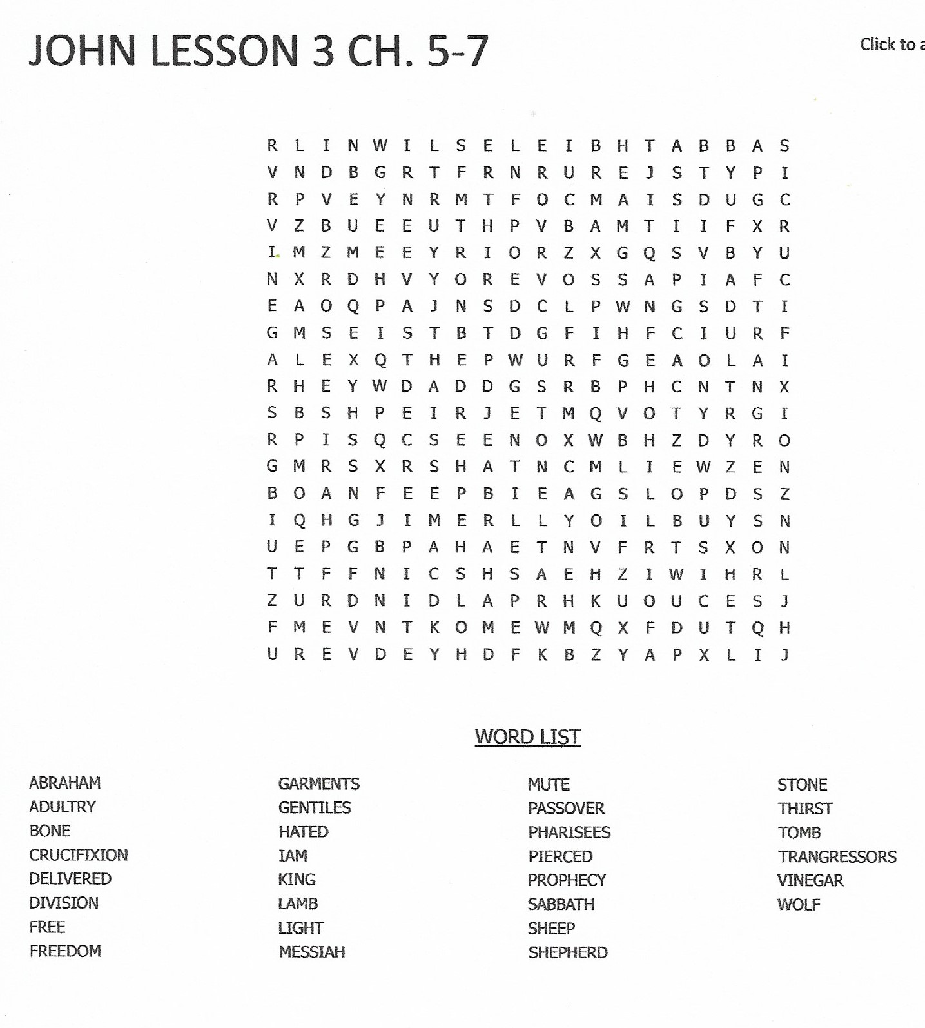

Use the space below for any questions or comments:
______________________________________________________________________________________________
______________________________________________________________________________________________
______________________________________________________________________________________________
______________________________________________________________________________________________
______________________________________________________________________________________________
______________________________________________________________________________________________
______________________________________________________________________________________________

I would like to be contacted by a minister in my area that can help me better understand God’s Word. If checked, please include a telephone number __________________________

Check Here For Change Of Address Or Housing.

RETURN COMPLETED LESSON TO:

Bible Correspondence Fellowship

Date: ____________________________________________________________________
Name: ___________________________________________________________________
Address: _________________________________________________________________
City: ____________________________ State: _______ Zip Code: ___________________
Country: _________________________________________________________________
E-mail Address (optional): ___________________________________________________

