
Gospel of John
Lesson 6
Chapter 18-19
Chapter 18
When we studied chapters 13-17 we learned that Jesus started His private ministry teaching His disciples about the New Covenant which involves the role of the Holy Spirit in their lives; giving comfort, encouragement and wisdom.
In Chapter 18 we will focus on Jesus being arrested, taken and interrogated before Annas, Caiaphas and Pilate. We also will watch Peter’s three denials of even knowing Jesus and saw the crowd choose a murderer and thief over Jesus, the giver of truth and life.

Please memorize the following verse and be prepared to write it out at the end of this lesson.
John 18:36, “Jesus answered, “My kingdom is not of this world. If My kingdom were of this world, My servants would fight, so that I should not be delivered to the Jews; but now My kingdom is not from here.”.
For better and complete understanding read Matt. 26; Lk. 22 & Mk. 14 Check _________
Read V1-14 and answer the following questions. Check _________
1. (V1) Where did Jesus go after He crossed the Kidron Valley? ____________________________________________
2. (V2-3) Who did Jesus meet? ______________________________________________________________________
3. (V4) Was Jesus surprised to meet Judas? Yes __________ No __________
4. (V5-7) Why might Jesus have the soldiers fall backward? _______________________________________________
_______________________________________________________________________________________________
All through Jesus’ life we saw His control over every situation, His crucifixion being no different. Jesus was always in control and only allowed the Jews to crucify Him because paying for humanity’s sins was the very reason Jesus came to earth (Jn. 1:29; 1 Tim. 1:15; 1 Jn. 2:2; Isa. 53:5; 2 Cor. 5:21).
5. (V8-9) What might have happened if Jesus was not willing to go with the soldiers? __________________________
_______________________________________________________________________________________________
6a. (V10) What did Peter do? _______________________________________________________________________
6b. Was Peter aiming for the person’s ear? _____________________________________________________________
6c. Why might Peter have been so willing to use his sword? (Jn. 13:37-38) ___________________________________
_______________________________________________________________________________________________

7. (V11) What “cup” could Jesus be referring to? (Matt. 26:39) ____________________________________________
Jesus who is willing to drink of the cup of the wrath of God, continues to show his main purpose for coming to earth, which is His obedience to the will of the Father. It was the Father’s will for Jesus to die for the sins of the world.
8. (V12-14) To whom did the soldiers bring Jesus to see? _________________________________________________
9. What was Caiaphas’ grand plan for Jesus? (Jn. 11:49-53) _______________________________________________
Read V15-27 and answer the following questions. Check _________
10. (V15-18) In your own words, summarize V15-18. ____________________________________________________
_______________________________________________________________________________________________
_______________________________________________________________________________________________
It is interesting that Jesus was bold to admit the truth by saying, “I am He”, while Peter was bold to deny the truth of Jesus by saying, “I am not”.
11. (V19) What did Annas question Jesus about? ________________________________________________________
_______________________________________________________________________________________________
12. (V19-21) Did Jesus try to hide anything? ___________________________________________________________
13. (V22-24) Why did the officer slap Jesus? ___________________________________________________________
John does not record the council of false witnesses as recorded in Matt. 26:59-62 and Mk. 14:55-60, where Jesus is questioned and beaten. Read Matt. 26, Mk. 14 and Lk. 23 for further understanding of Jesus’ ordeals.
Read V25-27 and answer the following questions. Check _________
14a. (V25-27) In Jn. 13:37-38 Peter made what promise? _________________________________________________
14b. (V17, 25-27) What did Peter do three times? ______________________________________________________
14c. (Matt. 26:69-75) What did Peter do after he heard the rooster crow? _____________________________________
Read V28-40 and answer the following questions. Check _________
15. (V28) Why would the Jewish leaders not enter into Pilate’s headquarters? _________________________________
16a. (V29-32) What specific charges did the Jews give to Pilate? ___________________________________________
16b. What was Pilate’s response? ____________________________________________________________________
The Jews responded with, “but we have no right to execute anyone” (V31). Whether actually they had the right or not, it did not stop them from trying to do so to Jesus. They tried to stone Him (Jn. 8:58; 10:30-33), push Him off the cliff (Lk. 4:28-30), and stoned Stephan in Acts 7:54-57).
17a. (V33-34) What question did Pilate ask Jesus? ______________________________________________________
17b. How did Jesus respond to Pilate’s question? _______________________________________________________
_______________________________________________________________________________________________

17c. Why might Jesus have said, “Is that your idea”? ____________________________________________________
_______________________________________________________________________________________________

18. (V36-37) How did Jesus answer the question, “Are you a king”? ________________________________________
_______________________________________________________________________________________________

19. (V38) What did Pilate say when Jesus mentioned the word, “Truth”? _____________________________________

20a. (V39-40) What was the custom during Passover that Pilate mentioned? __________________________________

20b. What were the two options? ____________________________________________________________________
20c. Who did the Jews choose to set free? _____________________________________________________________
21. Who did Jesus say He was in Ch. 18? ______________________________________________________________
_______________________________________________________________________________________________

_______________________________________________________________________________________________

22. What improvements in my life do I need to make to be able to live the Christ life in front of others? ____________

_______________________________________________________________________________________________

23a. Pilate asked, What is truth?” Is God’s word truth in your life, or is it mixed in with the world’s truth? __________
_______________________________________________________________________________________________

23b. What needs to be done to make God’s truth, your truth? ______________________________________________
_______________________________________________________________________________________________
Below is a possible chronology of the trials of Jesus using all 4 gospels with John as the main source.

Chapter 19
In chapter 18 we focused on Jesus being arrested, taken and interrogated before Annas, Caiaphas and Pilate. We also watched Peter’s three denials of even knowing Jesus and saw the crowd choose a murderer and thief over Jesus, the giver of truth and life.
In chapter 19 we will witness the event of the perfect person unjustly charged, found guilty of blasphemy by the Sanhedrin, accused of treason by Pilate and then crucified. It’s hard to be charged with blasphemy when you are who you say you are - the Son of God and the Messiah. We will see many prophecies completed during this ordeal. Finally, we will see Nicodemus prepare Jesus’s body for burial.
For better and complete understanding read Matt. 27; Mk. 15 & Lk. 23; Psa. 22 & 69 Check _________
Read V1-16 and answer the following questions. Check _________
1a. (V1-5) What did Pilate do to Jesus even though he did not find Him guilty? _______________________________

1b. What did the soldiers do? _______________________________________________________________________
_______________________________________________________________________________________________
2a. (V6-8) What did the chief priests and officers want to do with Jesus? ____________________________________
2b. What was Pilate’s advice? _______________________________________________________________________
2c. Why did the Jews want Jesus killed? ______________________________________________________________
2d. Why might Pilate be even more afraid? ____________________________________________________________
Pilate was afraid of a Jewish rebellion which would threaten his position and cause political instability throughout Rome, as well as validating a god other than Caesar. It is also interesting that the Jews wanted Rome to kill Jesus showing loyalty to Rome, and any blame for Jesus’ death would not fall back on the Jewish leadership.
3. (V9-11) What was Jesus’ response to Pilate’s questions? ________________________________________________
_______________________________________________________________________________________________
_______________________________________________________________________________________________

4a. (V12) What did Pilate continue to do with no avail? __________________________________________________
4b. What accusation would the Jews use against Pilate? __________________________________________________
4c. What would the accusation imply against Pilate? _____________________________________________________
5a. (V13-16) What was special about this day? _________________________________________________________
5b. How did the Jews reject Jesus as their God and Messiah? ______________________________________________
_______________________________________________________________________________________________
All 3 members of the trinity gave many opportunities to Israel for them to change their opinion of who God is.
1) The Father sent the prophets & John the Baptist to reach Israel – BUT they rejected the Father by killing John and the other prophets – STRIKE 1
2) The Father sent Jesus as their Messiah, their anointed One, their Deliverer to reach Israel (who was also speaking the words of the Father). BUT they rejected the Son by killing Him on the cross and wanted Rome to rule over them. – STRIKE 2.
3) Reading Acts Ch. 3-7 we see Israel rejected the Holy Spirit 3 times. The stoning of Stephan in Acts 7 was the last opportunity for Israel – STRIKE 3.
At this point, God put Israel aside (Rom. 9-11) and chose an entirely new program to reach the world with the gospel of salvation, the Body of Christ which will be completed at the rapture with the believers residing in heaven (1 Thess. 4:13-18). At that time God will begin working with Israel to again restore her (Jer. 31; Hosea 6; Rom. 11:26-27) and complete her mission of being a light to the Gentiles, that salvation may reach to the ends of the world (Isa. 49:6-7; Exo. 19:6).
Read V17-24 and answer the following questions. Check _________
6. (V17) What was the name of the place where Jesus was crucified? ________________________________________
7a. (V18-20) What writing did Pilate put on the title on the cross? __________________________________________
7b. What languages was the title written in? ___________________________________________________________
7c. Why might Pilate choose these three languages? _____________________________________________________
At that time, Hebrew was the language of the Jews religion; Greek was the language of commerce and Latin was the language of politics.
8a. (V21-22) Why were the chief priests not pleased with what Pilate had written? _____________________________
_______________________________________________________________________________________________
8b. What was Pilate’s response? _____________________________________________________________________
8c. Was what Pilate wrote on the sign actually correct? Yes ___________ No ___________
9a. (V23-24) What did the soldiers do with Jesus’ clothes? ________________________________________________
9b. What prophecy from Psa. 22:18 was fulfilled by the soldiers? ___________________________________________
_______________________________________________________________________________________________

Read V25-27 and answer the following questions. Check _________
10a. (V25-27) Who were the women that were by the cross? ______________________________________________
_______________________________________________________________________________________________
10b. Which disciple was also standing by the cross? _____________________________________________________
10c. What directions did Jesus give to His mother and the disciple? _________________________________________
_______________________________________________________________________________________________
Read V28-30 and answer the following questions. Check _________

To develop and mother son relationship
To develop and mother son relationship
11a. According to prophecy, what drink did they give Jesus? (Psa. 69:21) ____________________________________
11b. What were Jesus’ last words that John recorded? ____________________________________________________
11c. Jesus said, “it is finished”. What was finished? _____________________________________________________
_______________________________________________________________________________________________
Read V31-37 and answer the following questions. Check _________

To develop and mother son relationship
To develop and mother son relationship
12a. (V31-37) What were the soldiers going to do because the bodies could not remain on the cross? ______________
_______________________________________________________________________________________________
12b. What did the soldiers notice when they came to Jesus? _______________________________________________
12c. What prophecy from Psa. 34:20 & Zech. 12:10 was fulfilled? __________________________________________
12d. What did they do instead of breaking Jesus’ bones? __________________________________________________
Read V38-42 and answer the following questions. Check _________
13a. (V38-42) Who asked Pilate for Jesus’ body? _______________________________________________________
13b. Who brought a hundred pounds of spices to prepare Jesus’ body? _______________________________________
13c. Joseph and Nicodemus became bold to accept personal risk in asking Pilate and taking care of Jesus’ body. Is there a risk you have been avoiding or nervous about? ___________________________________________________
13d. What spice from the 3 wise men was used to prepare Jesus’ body? (Matt. 2:11)____________________________
14. Why is it important that so many Old Testament prophecies were fulfilled to the letter?_______________________
_______________________________________________________________________________________________
15. How did Jesus show who He was in Ch. 19? ________________________________________________________
_______________________________________________________________________________________________
16. What does Jesus’ death mean to you? ______________________________________________________________

17. What does Jesus dying on the cross say about our needs? ______________________________________________
_______________________________________________________________________________________________

Prophecies Fulfilled in John Ch. 19
# | Verse | Prophetic Reference | Prophecy
1 | 1 | Isa. 53:3-5 | Jesus was scourged
2 | 2 | Matt. 20:19 | Delivered over to the Gentiles
3 | 4 | Jn. 15:25; Psa.69:4 | Hated without a cause
4 | 5 | Zech. 6:12 | Behold, the man
5 | 6 | Jn. 3:14; Gal. 3:13 | Death was by crucifixion, not by stoning
6 | 7 | Gen. 22 | Anti-type of Isaac at Mt. Moriah
7 | 9 | Isa. 53:7 | Mute before his hearers
8 | 14 | Zech. 9:9 | Behold, the king
9 | 18 | Isa. 53:12 | Numbered with the transgressors
10 | 23 | Psa. 22:18 | Parted his garments
11 | 24 | Psa. 22:18 | Cast lots for his robe (coat)
12 | 25 | Lk. 2:25-35 | Mary a sword will pierce your heart
13 | 28 | Psa. 69:21 | Cried, 'I thirst'
14 | 29 | Psa. 69:21 | Gave vinegar to Jesus to drink
15 | 30 | Jn. 10:17-18 | He gave up the ghost
16 | 31 | Ex. 12 | Type of Passover
17 | 32 | Psa. 34:20 | Not a bone broken
18 | 37 | Zech. 12:10 | Pierced his side - they shall look upon Me
19 | 40 | Isa. 53:9 | Buried in a rich man's tomb
Please write out John 18:36 from memory___________________________________________________________
_______________________________________________________________________________________________
_______________________________________________________________________________________________
_______________________________________________________________________________________________

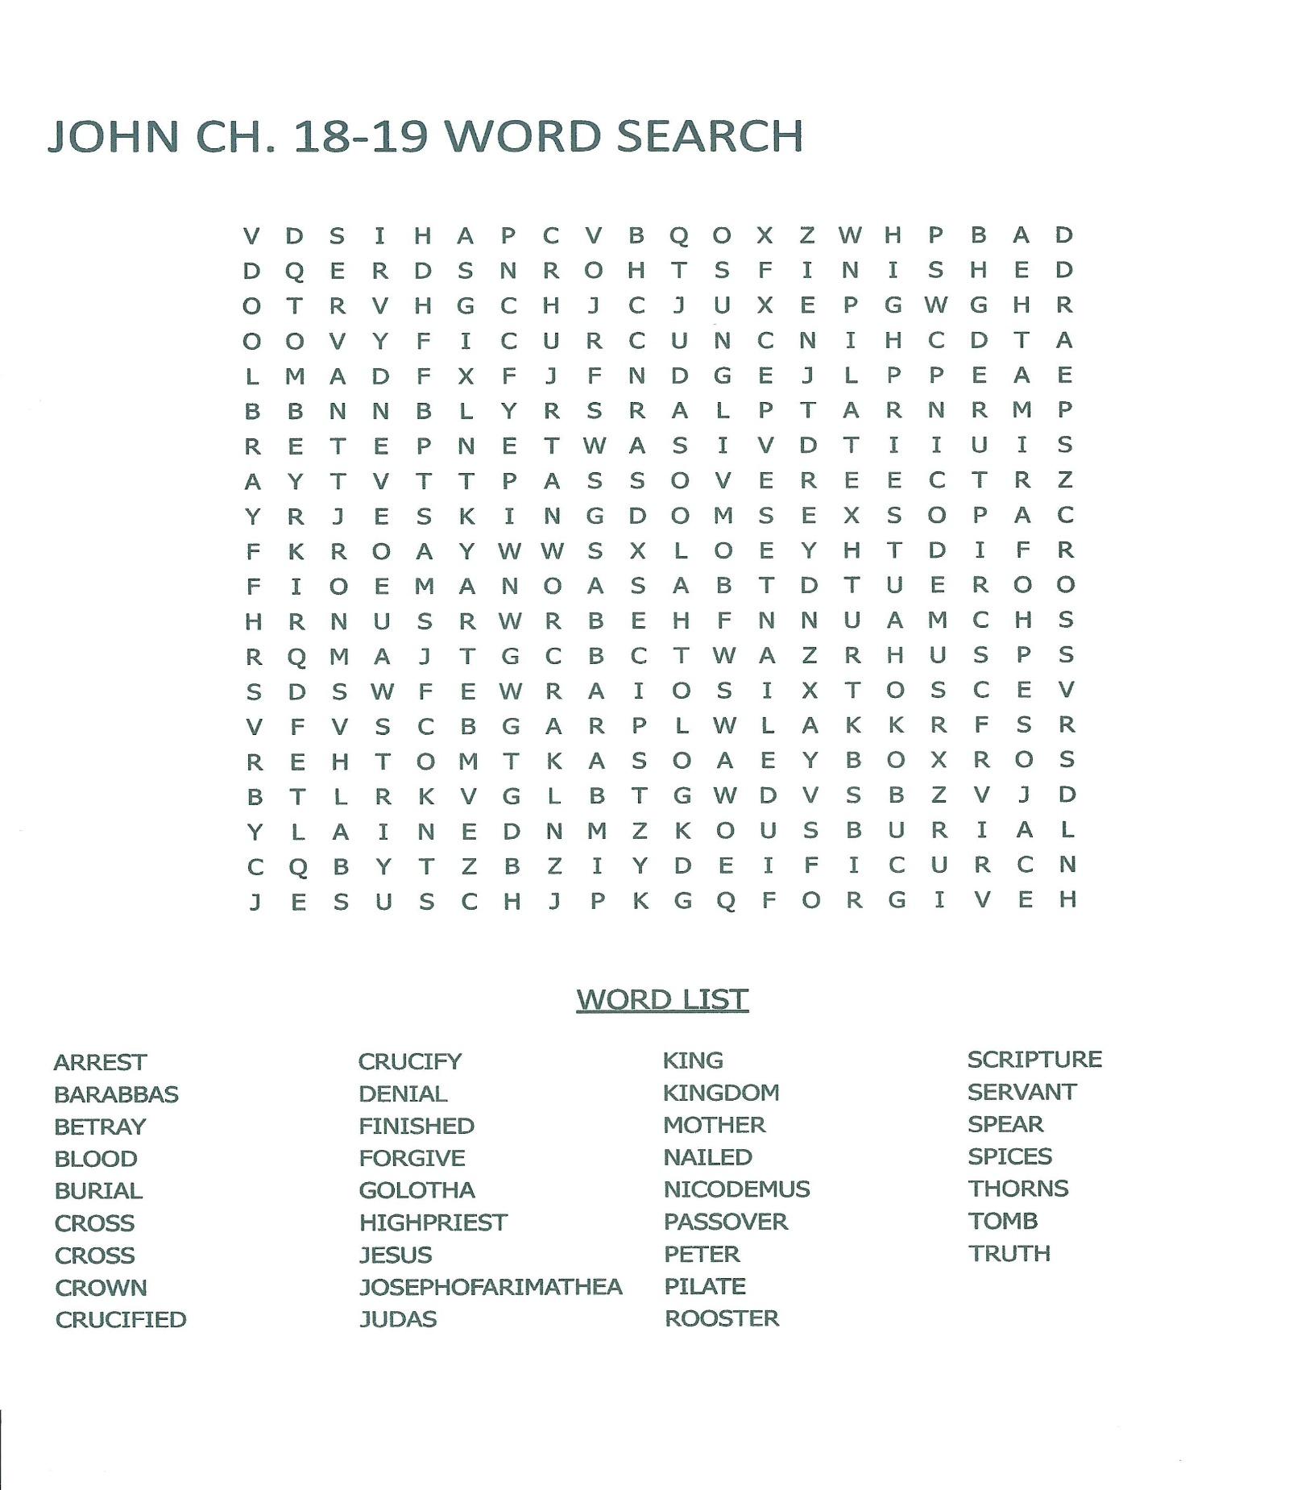
Use the space below for any questions or comments:
______________________________________________________________________________________________
______________________________________________________________________________________________
______________________________________________________________________________________________
______________________________________________________________________________________________
______________________________________________________________________________________________
______________________________________________________________________________________________
______________________________________________________________________________________________

I would like to be contacted by a minister in my area that can help me better understand God’s Word. If checked, please include a telephone number __________________________

Check Here For Change Of Address Or Housing.

RETURN COMPLETED LESSON TO:

Bible Correspondence Fellowship

Date: ____________________________________________________________________
Name: ___________________________________________________________________
Address: _________________________________________________________________
City: ____________________________ State: _______ Zip Code: ___________________
Country: _________________________________________________________________
E-mail Address (optional): ___________________________________________________

