
Gospel of John
Lesson 7
Chapter 20-21
Chapter 20

In Chapter 19 we saw Jesus’ arrest in the Garden of Gethsemane, Jesus’ interrogation before Annas and Caiaphas, Peter's three denials, and Jesus before Pilate, who asked the question, “What is truth?” to the embodiment of truth standing before him. After being politically blackmailed by the Jewish leadership, Pilate authorized Jesus' crucifixion and ordered a plaque to be placed on the cross with the inscription "King of the Jews." After Jesus' side is pierced with a spear to confirm His death, His body was placed in a new tomb. Joseph of Arimathea and Nicodemus prepared His body for burial.
In Chapter 20 we will see Mary Magdalene and the some of the apostles examine the empty tomb assuming someone has taken the body. Jesus then appears to His followers proving that He is alive, however Thomas doubts and will not believe until he touches Jesus’ scars. John gives the purpose of his writing, and concludes by explaining the purpose of his record: “these are written so that you may believe Jesus is the Christ, the Son of God, and that through believing, you may have life in His name” (John 20:31).

Please memorize the following verse and be prepared to write it out at the end of this lesson.
John 20:30-31 “And truly Jesus did many other signs in the presence of His disciples, which are not written in this book; ³¹ but these are written that you may believe that Jesus is the Christ, the Son of God, and that believing you may have life in His name”.
For better and complete understanding read Matt. 28; Mk. 16 & Lk. 24; Check _________
Read V1-10 and answer the following questions. Check _________
1a. (V1-2) What happened to the stone covering the entrance to the tomb? ___________________________________
1b. (Matt. 28) Who rolled away the stone? _____________________________________________________________
1c. Who saw that the stone was removed from the opening? _______________________________________________
1d. (Matt. 28) What did the angel invite the two Marys’ to do? _____________________________________________
1e. What did Mary Magdalene initially assume when she saw the stone rolled away?
A. Jesus had risen
B. The disciples had taken Jesus' body
C. Someone had taken the Lord’s body
D. The tomb had collapsed
1f. What did Mary do after seeing the empty tomb? ______________________________________________________
2a. (V3-10) Who were the two disciples that ran to the tomb? ______________________________________________
2b. What did Peter see that was interesting? ____________________________________________________________
_______________________________________________________________________________________________
2c. What does it mean that the head covering was in a different place from the linen cloths? _____________________
_______________________________________________________________________________________________
_______________________________________________________________________________________________
2d. Did the two disciples finally realize that Jesus needed to die for their sins and be resurrected? Yes ____ No _____
Read V11-18 and answer the following questions. Check _________
3. (V11-18) Who saw the two angels sitting in the tomb?_________________________________________________
4a. (V13-15) What did the angels say to her? ___________________________________________________________
4b. What did Jesus say to her? ______________________________________________________________________
4c. Who did she suppose the stranger to be? ___________________________________________________________
4d. What did Mary want from the stranger?____________________________________________________________
4e. Why might Mary not have recognized Jesus? _______________________________________________________
_______________________________________________________________________________________________
5a. (V16-18) How did Mary realize it was Jesus standing in front of her? ____________________________________
5b. What did Jesus say to Mary? _____________________________________________________________________
_______________________________________________________________________________________________
_______________________________________________________________________________________________

5c. Why would Mary want to cling to Jesus?___________________________________________________________
_______________________________________________________________________________________________

5d. Why would Jesus say to Mary, do not cling to me? ___________________________________________________
_______________________________________________________________________________________________
5e. Did Mary do as she was told? Yes __________ No __________
5f. Do you cling to Jesus today? _____________________________________________________________________

Read V19-23 and answer the following questions. Check _________
6a. In what two ways did Jesus show He was God? _____________________________________________________
_______________________________________________________________________________________________
6b. What did Jesus say to the disciples to calm their hearts after he walked through the door? ____________________
7a. (V22-23) What gift did Jesus give the disciples? _____________________________________________________
7b. What does this gift allow the disciples to do? ________________________________________________________
For better and complete understanding read Matt. 28; Mk. 16 & Lk. 24; Check _________
Read V24-31 and answer the following questions. Check _________
8a. (Matt. 28) What happened to make the Roman guards afraid and faint? ___________________________________
_______________________________________________________________________________________________
8b. How did the chief priests try to “fix” the problem of what happened to the soldiers? _________________________
_______________________________________________________________________________________________

9a. (V24-29) What did it take for Thomas to believe that Jesus rose from the dead? ____________________________
_______________________________________________________________________________________________

9b. What did Thomas say when he finally saw Jesus?
A. “You have returned.”
B. “I believe now.”
C. “My Lord and my God!”
D. “Is it really you?”
9c. What did Jesus say about those who have not physically seen and yet believe?______________________________
_______________________________________________________________________________________________

Questions 10a – 10g are from Luke 24
10a. (Lk. 24) Jesus met two men on the road to Emmaus. What hope did these two men have that they felt was dashed by Jesus’ death? __________________________________________________________________________________
_______________________________________________________________________________________________

10b. What did Jesus use to show that they should have believed in the resurrection? ____________________________
_______________________________________________________________________________________________

10c. What word or words did the two from Emmaus use to describe how God’s words affected them? _____________
_______________________________________________________________________________________________
10d. Do you have a burning desire to understand God’s word? Yes _________ No ___________ If not, why not?
_______________________________________________________________________________________________

10e. What did the two men do next? __________________________________________________________________
10f. Jesus then appears to His disciples and they did not yet believe. What did Jesus do to prove He was not just a spirit or ghost? _______________________________________________________________________________________
_______________________________________________________________________________________________
10g. What did Jesus use to help their understanding of His death, burial and resurrection? _______________________
______________________________________________________________________________________________
11a. (Jn. 20:30-31) Did John record all of Jesus’ signs and miracles? Yes _________ No __________
11b. John recorded Jesus’ words and works. What was John trying to prove? __________________________________
_______________________________________________________________________________________________
_______________________________________________________________________________________________

When Jesus was on the cross, He took all of humanity’s sins upon Himself and took the punishment that you and I are guilty of. 2 Cor. 5:21 tells us that, “God made Him who had no sin to be sin for us, so that in Him we might become the righteousness of God”. This means that when Jesus became sin for us, He carried our sins away as far as the East is from the West (Psa. 103:12).
When Jesus said, “It is finished”, He fully accomplished all that the Father had for Him to do while here on earth. When Jesus resurrected on that Sunday morning, it was the “proof of purchase”, the receipt that showed Jesus’ payment was totally effective and accepted by the Father. The resurrection of Jesus proved that His work on the cross was successful and the empty tomb was the visible proof that the work of redemption was finished.
Because of Jesus’ resurrection, the believer acquired the righteousness of God. That is, God’s righteousness has been applied to our account, so that, when the Father looks at the believer, He only sees Christ’s righteousness.
The resurrection shows that Jesus was not only victorious over death for Himself, but also victorious for the believer as well (Acts 2:24; 1 Cor. 15:20-22). Christ in the believer has many benefits both here and now and even better later in eternity. While on this earth, the Holy Spirit resides in the believer to bring many, many benefits such as: peace, hope, assurance of salvation, guidance, participation in carrying out God’s will, being drawn closer to the image of Christ and a daily relationship with God who hears and is able to act.
12. How did Jesus show who He was in Ch. 20? ________________________________________________________
_______________________________________________________________________________________________
_______________________________________________________________________________________________
13. What does Jesus’ resurrection mean to you? _________________________________________________________
14. What in this chapter has made an impact to you? _____________________________________________________
15. What in this chapter would you like to understand better? ______________________________________________
_______________________________________________________________________________________________
Chapter 21
In Chapter 20 we learned of the resurrection from John’s perspective and also looked at the other three gospel writers. The Roman soldiers fainted from seeing the angels and experiencing the stone being moved away during the earthquake. Mary Magdalene found the tomb empty and Jesus told her to tell His followers what she had seen. Jesus commissioned the apostles with the Holy Spirit and later revealed Himself to Thomas and two men on the Emmaus road. John concluded the chapter by giving His reason for selecting certain miracles and events, “But these are written that you may believe that Jesus is the Messiah, the Son of God, and that by believing you may have life in his name” (V31).
In Chapter 21 we will see Jesus preparing breakfast by the sea, Peter's restoration, questions about John’s future and a concluding statement mentioning the inability of being able to write down everything that Jesus did.
Read V1-14 and answer the following questions Check _________
1a. (1-6) Whose idea was it to go fishing? Matthew ______ Mark ______ Luke ______ John_______ Peter ______
1b. Did they catch anything? Yes __________ No __________
1c. When Jesus called them, what did He call them? _____________________________________________________
The NIV uses the word “friends” and the KJV uses the word “children”. This Greek word means, “a childling (of either sex), that is, (properly) an infant, or (by extension) a half-grown boy or girl; figuratively an immature Christian. It is used of the infant Jesus (Matt. 2:8-9; and the nobleman’s son in Jn. 4:49).
1d. Why would Jesus call these grown fisherman “children”? ______________________________________________ Does 1 Jn. 2:13 help?
1e. What does Jesus direct them to do? _______________________________________________________________
These are professional fishermen and know very well how to fish and on what side of the boat to fish from according to the time of day.
1f. So, why do you think Jesus might have told them to fish on the wrong side of the boat? ______________________
_______________________________________________________________________________________________
2a. (V7-14) Why might the unnamed disciple realize that it was the Lord who gave directions? ___________________
_______________________________________________________________________________________________
2b. Who wanted to see the Lord so badly that he jumped into the water and left the others to bring in the load of fish?
Choose one: John_____ Peter_____ James_____ Judas_____ Andrew _____ Matthew _____ Jude _____
2c. What did the disciples see when they got to shore? ___________________________________________________
2d. How many fish did they catch? 97_____ 121_____ 152_____ 153 ____ 159 _____ 186 _____
2e. What was the quality or size of the fish? Minnow size ______ Average ______ Large _____ Whale size ______
2f. What was noted about the net? So many it ripped open ______ It didn’t break ______ The high quality ______
2g..How many times did Jesus meet with His disciples after his resurrection? 2_____ 3_____ 4_____ ?_____
Read V15-23 and answer the following questions Check _________
3a. (15-19) Jesus said, “do you love me more than these”? What might Jesus be referring to?
Prepared breakfasts _____ Fish ______ The other disciples ______ Unknown ______
3b. What was Peter's response to Jesus’ questions? ______________________________________________________
3c. How many times did Jesus ask the same question? 1 _____ 2_____ 3_____ 4______ Peter lost count ______
3d. Why might Peter feel hurt that Jesus’ asked him, do you love me 3 times? _________________________________
_______________________________________________________________________________________________
3e. What was Jesus’ response to Peter's declaration of love? _______________________________________________
4. (V18-19) What is Jesus referring to when He said, “when you are old you will stretch out your hands, and someone else will dress you and lead you where you do not want to go.”
A) He will have dementia and live at a senior center __________ C) He will die a martyr _________
B) He will die in prison _________ D) Other ________
Peter's restoration was foremost in Jesus’ mind and purpose. In chapter 18 we saw Peter denying the Lord three times and then Peter's grief and regret of denying of even knowing the Lord. We now see Jesus restoring Peter to full fellowship and a close relationship to Himself. Showing full confidence, Jesus gives Peter a new mission of feeding other believers and how he will die as a faithful and loyal man of God.
Restoration is very important, whether it be our restoration back to God (God is aways wanting to restore), or to our spouse, our children, bosses, friends or even enemies. My relationship with my heavenly Father is extremely important to me. When I realize my fault (sin), I admit my wrong and ask Him for help to not do that thing or thought again. I need not ask for forgiveness because all my sins have already been forgiven at the cross (past, present and future). It is important to believe and move on with God and not participate in the emotions of self-blame.
Read V20-25 and answer the following questions Check _________
5a. (V20-21) What rumor spread because of Jesus' words about the beloved disciple?
A. He was not a real disciple
B. He would write many books
C. He would not die
D. He was a prophet
5b. Why might Peter ask about the other disciple? _______________________________________________________
6. (V22-23) What was Jesus’ response?________________________________________________________________
7. (V24) Who might be the unnamed disciple? _________________________________________________________
8. (V25) What size of a library would be needed to house all the books telling what Jesus did? ___________________
_______________________________________________________________________________________________
9. What does Ch. 21 tell us about ourselves? ___________________________________________________________
_______________________________________________________________________________________________
_______________________________________________________________________________________________
10. How did Jesus show who He was in Ch. 21? ________________________________________________________
_______________________________________________________________________________________________
_______________________________________________________________________________________________

11. What is the most significant thing you learned in the book of John? ______________________________________
_______________________________________________________________________________________________
_______________________________________________________________________________________________
12. What changes will you make in your life? __________________________________________________________
_______________________________________________________________________________________________
_______________________________________________________________________________________________
Please write out John 20:30-31 from memory __________________________________________________________
_______________________________________________________________________________________________
_______________________________________________________________________________________________
_______________________________________________________________________________________________
_______________________________________________________________________________________________

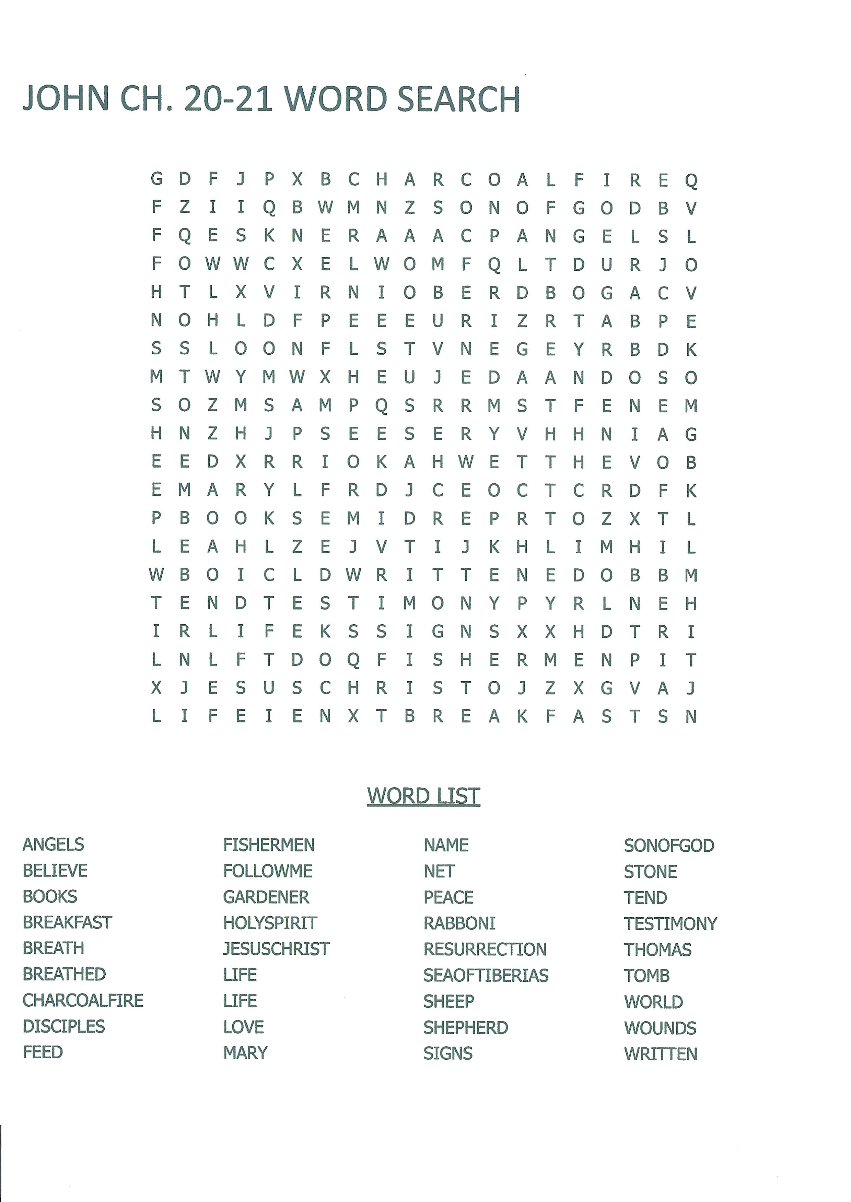
Use the space below for any questions or comments:
______________________________________________________________________________________________
______________________________________________________________________________________________
______________________________________________________________________________________________
______________________________________________________________________________________________
______________________________________________________________________________________________
______________________________________________________________________________________________
______________________________________________________________________________________________

I would like to be contacted by a minister in my area that can help me better understand God’s Word. If checked, please include a telephone number __________________________

Check Here For Change Of Address Or Housing.
RETURN COMPLETED LESSON TO:

Bible Correspondence Fellowship

Date: ____________________________________________________________________
Name: ___________________________________________________________________
Address: _________________________________________________________________
City: ____________________________ State: _______ Zip Code: ___________________
Country: _________________________________________________________________
E-mail Address (optional): ___________________________________________________

